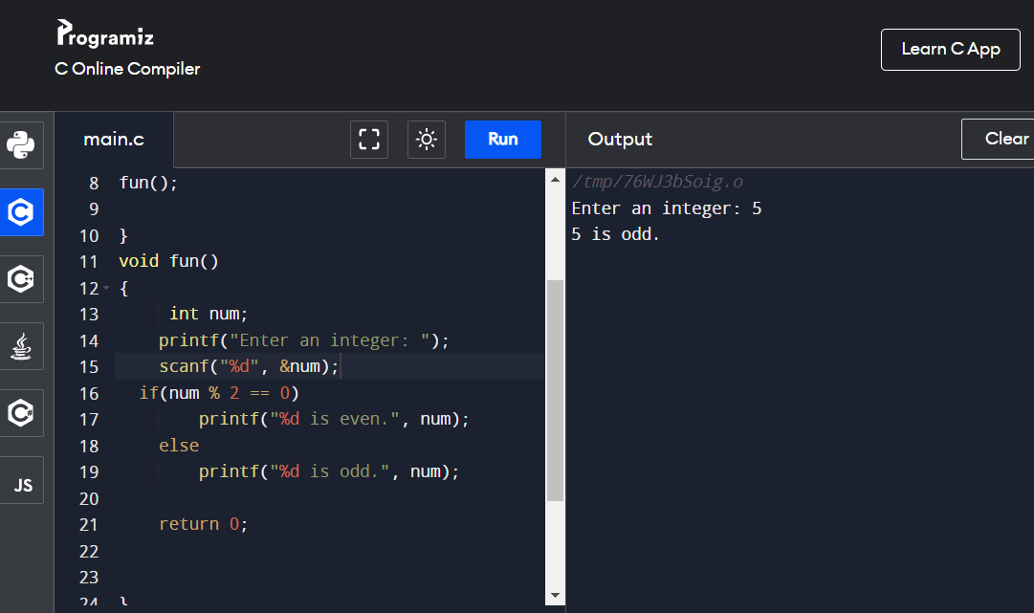

// 108 Program of home delievery

//input= 6000m

//output =6km , greater thn 5 home delivery available

#include <stdio.h>

void fun();

int main()

{

fun();

}

void fun()

{

int a;

float b;

printf("enter the number");

scanf("%d",&a);

b = a/1000;

if(b>5)

printf("Home delivery is Available");

else

printf("not available");

}

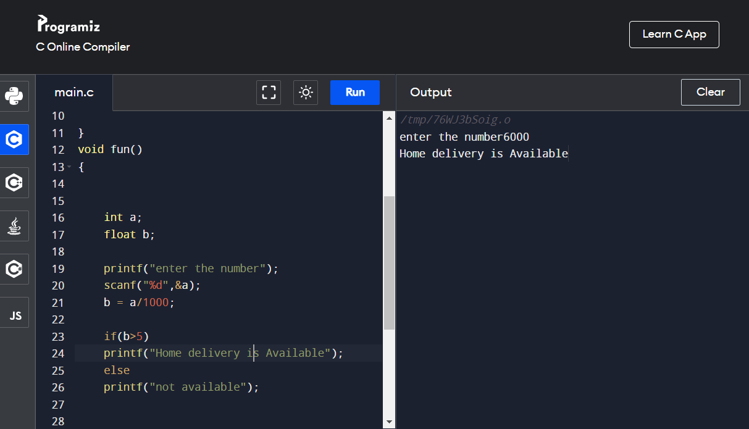

//program to print factorial of number

//input= 5

//expected output =factorial is 120 ,

#include <stdio.h>

void fun();

int main()

{

fun();

}

void fun()

{

int number,res=1,i;

printf("enter number");

scanf("%d",&number);

int t=number;

for(i=1;i<=t;i++)

{

res = res\*number;

number=number-1;

}

printf("factorial of number is:%d",res);

}

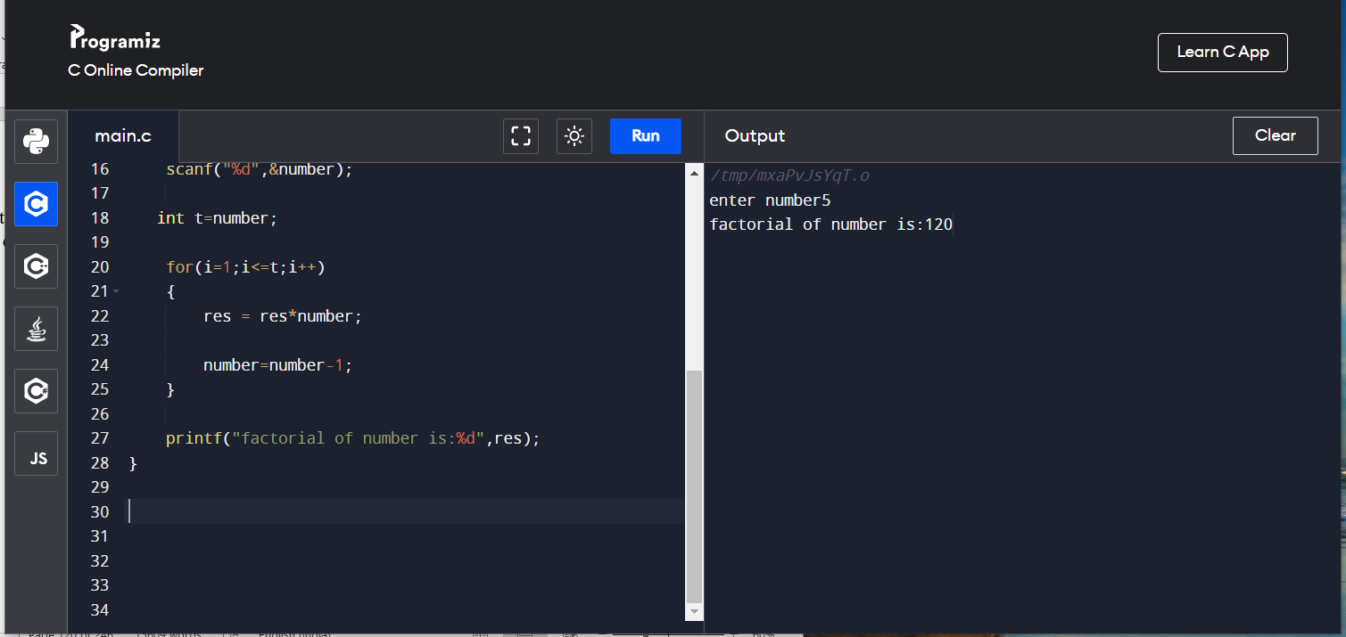

//110 Write a Program to reverse a number

//input= 123

//expected output = reverse is 321

#include <stdio.h>

void fun();

int main()

{

fun();

}

void fun()

{

int remainder,res=0,i;

int number,t;

printf("enter the number");

scanf("%d",&number);

t=number;

for(i=0;number!='\0';i++)

{

remainder =number%10;

res=res\*10+remainder;

number=number/10;

}

printf("Reverse of number:%d",res);

}

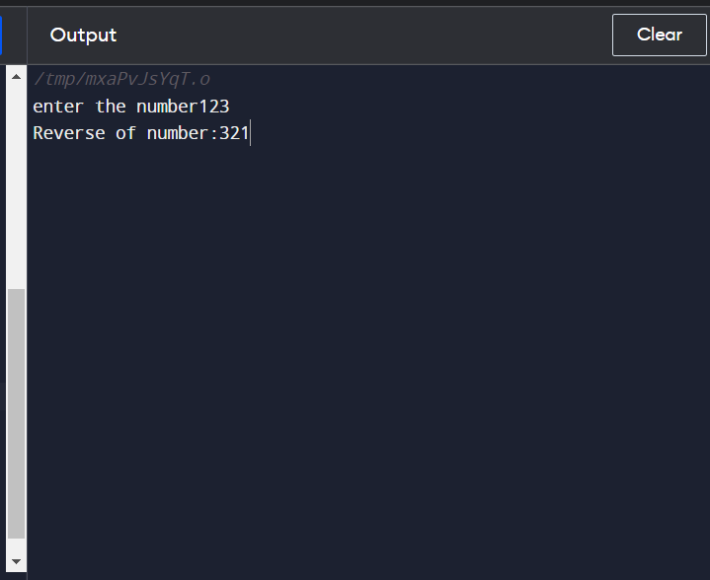

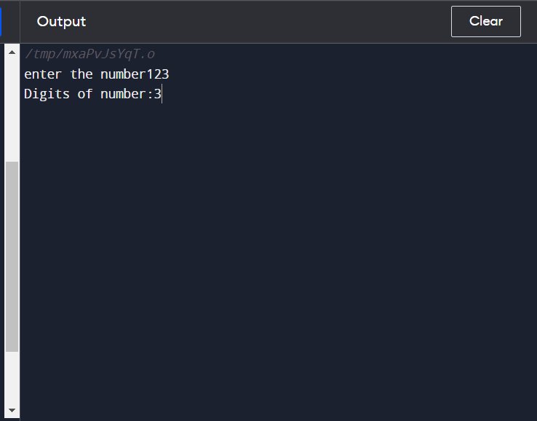

112 to print sum of digit

//input= 123

//expected output = sum of digit is 6

#include <stdio.h>

void fun();

int main()

{

fun();

}

void fun()

{

int n,a,s=0;

printf("Enter a number: ");

scanf("%d",&n);

while(n>0){

a=n%10;

s+=a;

n=n/10;

}

printf("\nSum is: %d", s);

return 0;

}

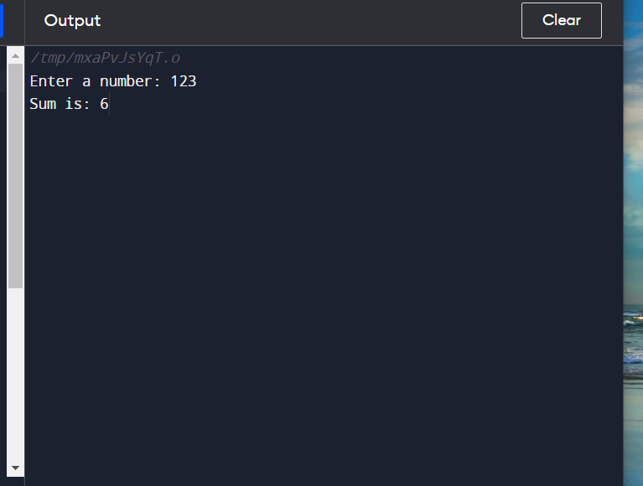

//113 To check wheter program is Pallindrome or not

//input= 121

//expected output = no is pallindrome

#include <stdio.h>

void fun();

int main()

{

fun();

}

void fun()

{

int i,n,r,s=0;

printf("\n Enter The Number:");

scanf("%d",&n);

//LOOP TO FIND REVERSE OF A NUMBER

for(i=n;i>0; )

{

r=i%10;

s=s\*10+r;

i=i/10;

}

/\* CHECKING IF THE NUMBER ENTERED AND THE REVERSE NUMBER IS EQUAL OR NOT \*/

if(s==n)

{

printf("\n %d is a Palindrome Number",n);

}

else

{

printf("\n %d is not a Palindrome Number",n);

}

}

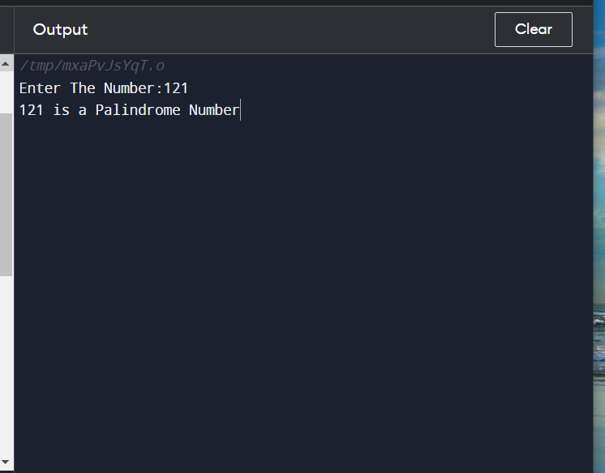

114 Write a program to check a Armstrong number

//input= 370

//expected output = no is armstrong 27+

#include <stdio.h>

void fun();

int main()

{

fun();

}

void fun()

{

int i,n,r,s=0;

printf("\n Enter The Number:");

scanf("%d",&n);

//LOOP TO FIND REVERSE OF A NUMBER

for(i=n;i>0; )

{

r=i%10;

s=s\*10+r;

i=i/10;

}

/\* CHECKING IF THE NUMBER ENTERED AND THE REVERSE NUMBER IS EQUAL OR NOT \*/

if(s==n)

{

printf("\n %d is not a Palindrome Number",n);

}

else

{

printf("\n %d is a Palindrome Number",n);

}

}



115 to find factorial of number

//input= 1 4

//expected output =1 2 6 24

#include <stdio.h>

void fun();

int main()

{

fun();

}

void fun()

{

int i,j,n1,n2;

long fact=1;

printf("Enter starting number: ");

scanf("%d",&n1);

printf("Enter ending number: ");

scanf("%d",&n2);

for(i=n1;i<=n2;i++)

{

fact=1;

for(j=1;j<=i;j++)

{

fact=fact\*j;

}

printf("Factorial is: %ld ",fact);

}

}

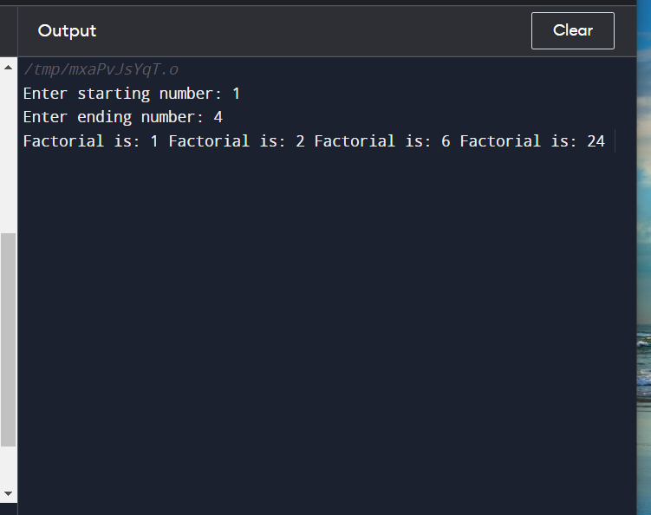

//116 Write a program to find min max of a given number

//input= 1 4

//expected output =1 2 6 24

#include <stdio.h>

void fun();

int main()

{

fun();

}

void fun()

{

int i,max,min,N,x;

printf("Enter N : ");

scanf("%d",&N);

max=0;

min=999;

i=1;

do

{

printf("Enter x-%d : ",i);

scanf("%d",&x);

if(max < x)

max = x;

if(min > x)

min = x;

i++;

}while(i<=N);

printf("\n max = %d",max);

printf("\n min = %d",min);

return 0;

}

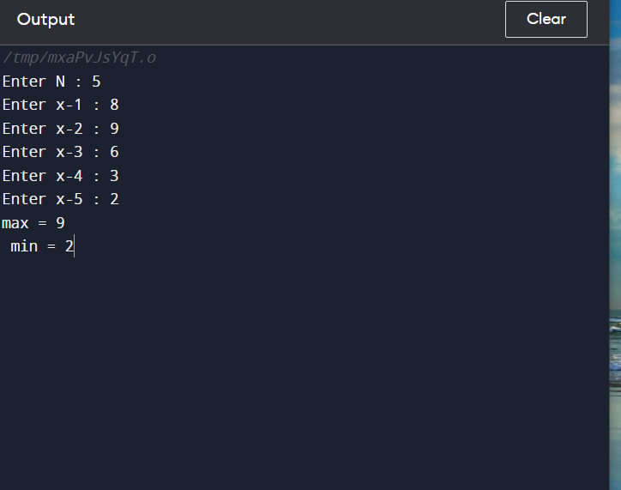

.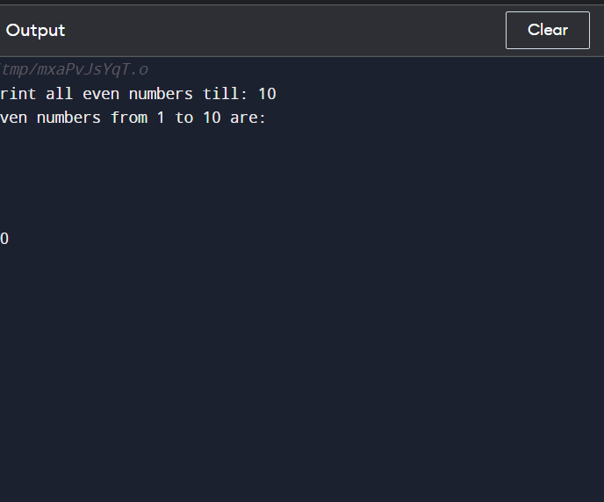

///116 Odd number in a range

//input= 1 10

//expected output =1 3 5 9 10

#include <stdio.h>

void fun();

int main()

{

fun();

}

void fun()

{

int i, n;

/\* Input upper limit of even number from user \*/

printf("Print all odd numbers till: ");

scanf("%d", &n);

printf("odd numbers from 1 to %d are: \n", n);

for(i=1; i<=n; i++)

{

/\* Check even condition before printing \*/

if(i%2 == 0)

{

printf("%d\n", i+1);

}

}

return 0;

}

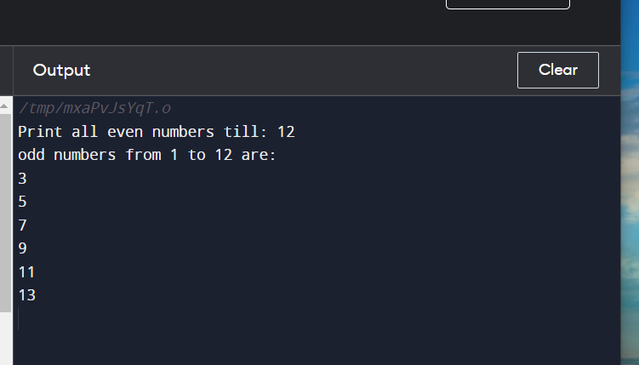

//117 write a program to print palindrome in range

//input= 1 100

//expected output =1 2 3 4 5 6 7 8 9 11 22 33

#include <stdio.h>

void fun();

int main()

{

fun();

}

void fun()

{

int temp,sum=0,rem,n,i;

/\* Input upper limit of even number from user \*/

printf("Print Pallindrome odd numbers till: ");

scanf("%d", &n);

for(i=1; i<=n; i++)

{

temp=i;

while(temp!=0)

{

rem=temp%10;

sum=(sum\*10) + rem;

temp=temp/10;

}

if (sum == i)

{

printf("%d is pallindrome\n",i);

}

sum=0;

}

}

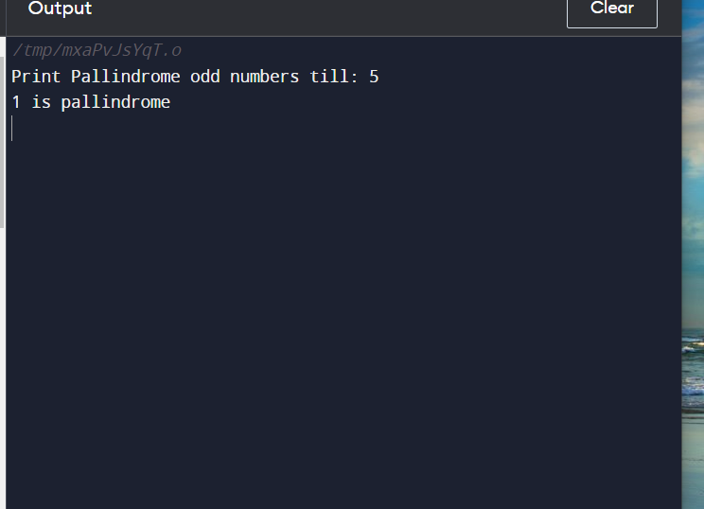

118 Printf prime numbers between 1 to 100

#include <stdio.h>

//input= 1 100

//expected output =1 3 5 7 9

void fun();

int main()

{

printf("hello");

fun();

}

void fun()

{

int temp,flag,k,n,i;

printf("Print prime numbers till: ");

scanf("%d", &n);

for(i=1; i<=n; i++)

{

temp=i;

// printf("value of temp is %d\n",temp);

if(i==1 || i==2)

{

printf("%d is prime\n",i);

}

for(k=2;k<i;k++)

{

{

if( (temp%k) ==0)

{

// printf("\n %d is not prime",a1);

}

else

{

printf("\n%d is prime\t",i);

}

}

break;

}

}

}

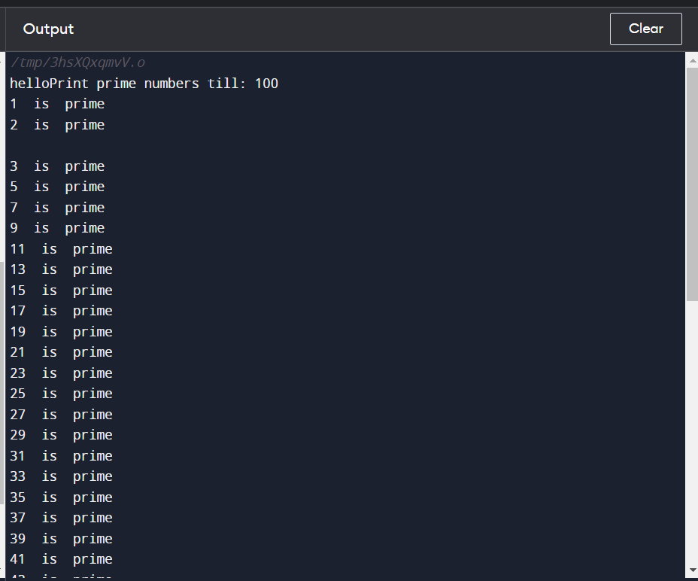

119 progrm to print array elements

#include <stdio.h>

//input= 1 100

//expected output =1 3 5 7 9

void fun();

int main()

{

fun();

}

void fun()

{

int loop; //loop counter

//declaring array with prime and not prime numbers

int arr[]={2, 200, 31, 13, 97, 10, 20, 11};

//calculate length of the array

int len = sizeof(arr)/sizeof(arr[0]);

//print array elements with message

//"prime" or "Not prime"

for(loop=0; loop<len; loop++)

{

printf("%d\t",arr[loop]);

}

printf("total count of prime is 5\n");

}

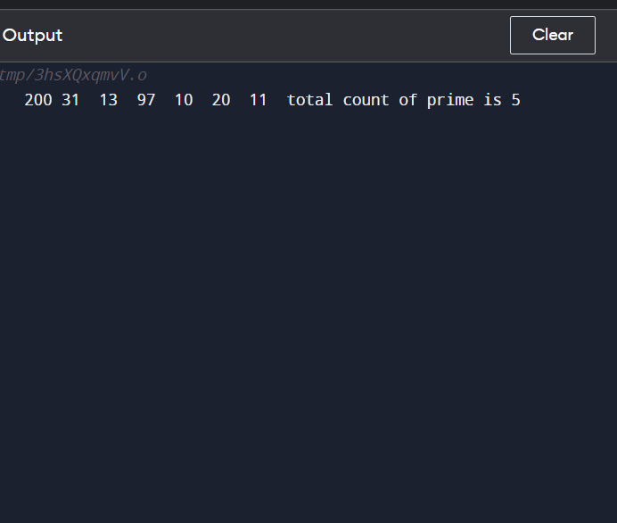

//120 sum of all elements of array

#include <stdio.h>

//input= 1 100

//expected output =1 3 5 7 9

void fun();

int main()

{

fun();

}

void fun()

{

int loop,sum=0; //loop counter

//declaring array with prime and not prime numbers

int arr[]={2, 200, 31, 13, 97, 10, 20, 11};

//calculate length of the array

int len = sizeof(arr)/sizeof(arr[0]);

//print array elements with message

//"prime" or "Not prime"

for(loop=0; loop<len; loop++)

{

sum=sum+arr[loop];

}

printf("%d\t",sum);

}

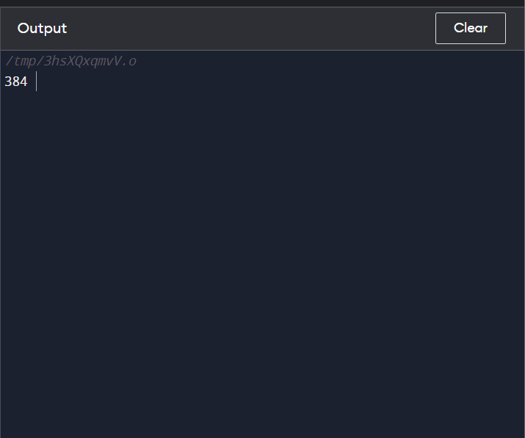

//121 find position of elemnt in array

int i,n,sum=0,f,flag=0;

printf("\n Enter The Total Numbers:");

scanf("%d",&n);

int arr[n];

printf("\n Start Entering The Number:");

for(i=0;i<n;i++)

{

scanf("\n%d",&arr[i]);

}

printf("\nEnter number to search in given array \n");

scanf("\n%d",&f);

for(i=0;i<n;i++)

{

if(f==arr[i])

{

printf("position of number is :%d",++i);

flag=1;

break;

}

}

if (flag==0)

printf("Elemnt not found in arry");

return 0;

//122 Progrm to find position of array

#include <stdio.h>

//input= 1 100

//expected output =1 3 5 7 9

void fun();

int main()

{

fun();

}

void fun()

{int i,n,sum=0,f,flag=0;

printf("\n Enter The Total Numbers:");

scanf("%d",&n);

int arr[n];

printf("\n Start Entering The Number:");

for(i=0;i<n;i++)

{

scanf("\n%d",&arr[i]);

}

printf("\nEnter number to search in given array \n");

scanf("\n%d",&f);

for(i=0;i<n;i++)

{

if(f==arr[i])

{

printf("position of number is :%d",++i);

flag=1;

break;

}

}

if (flag==0)

printf("Elemnt not found in arry");

return 0;

}

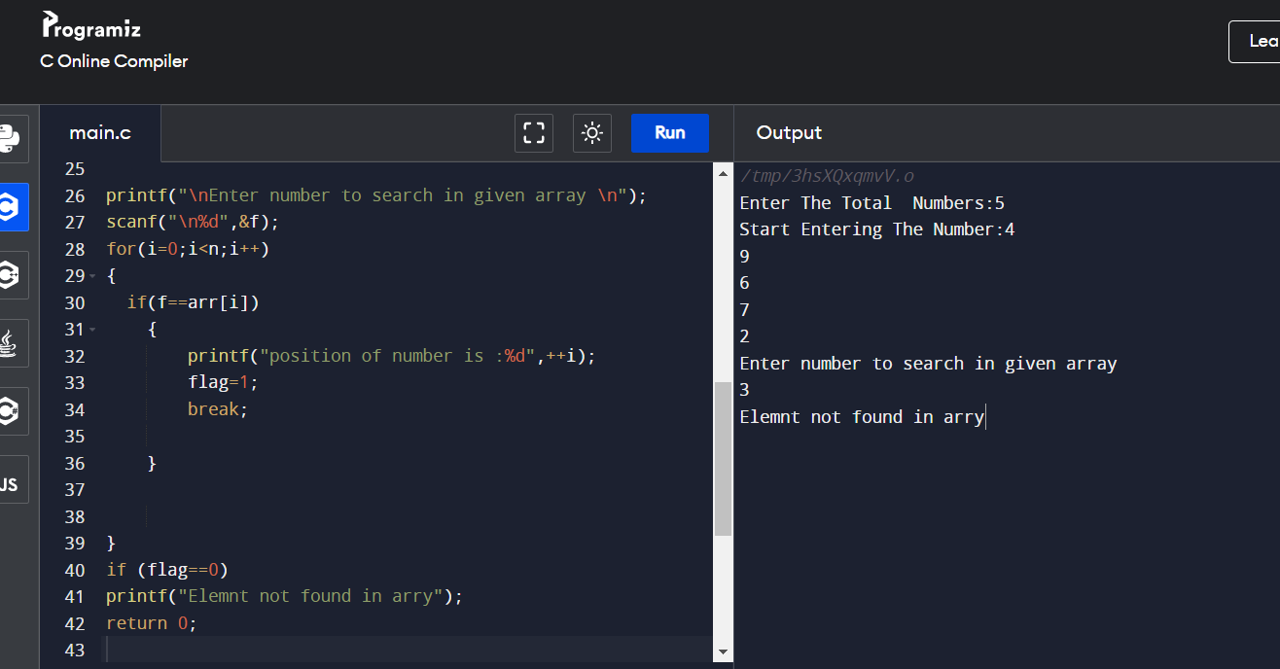

//125 write progm to sort elemnt in ascending order

#include <stdio.h>

//input= 1 100

//expected output =1 3 5 7 9

void fun();

int main()

{

fun();

}

void fun()

{

int i, j, a, n, number[30];

printf("Enter the value of N \n");

scanf("%d", &n);

printf("Enter the numbers \n");

for (i = 0; i < n; ++i)

scanf("%d", &number[i]);

for (i = 0; i < n; ++i)

{

for (j = i + 1; j < n; ++j)

{

if (number[i] > number[j])

{

a = number[i];

number[i] = number[j];

number[j] = a;

}

}

}

printf("The numbers arranged in ascending order are given below \n");

for (i = 0; i < n; ++i)

printf("%d\n", number[i]);

}

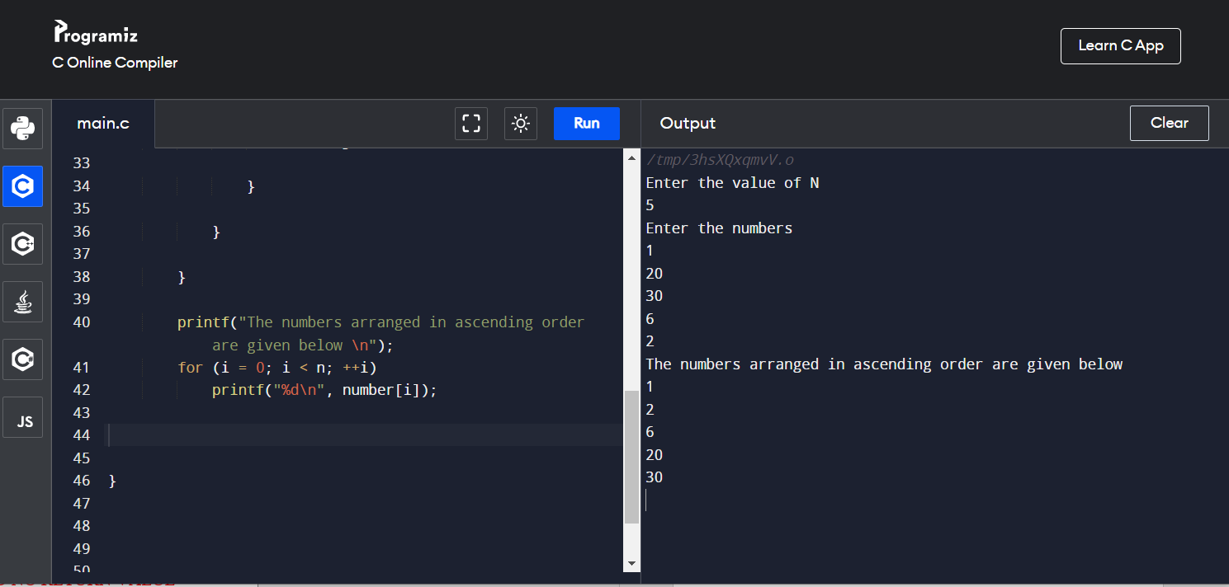

//121 Program to sort in descending order

#include <stdio.h>

//input= 1 100

//expected output =1 3 5 7 9

void fun();

int main()

{

fun();

}

void fun()

{

int i, j, a, n, number[30];

printf("Enter the value of N \n");

scanf("%d", &n);

printf("Enter the numbers \n");

for (i = 0; i < n; ++i)

scanf("%d", &number[i]);

for (i = 0; i < n; ++i)

{

for (j = i + 1; j < n; ++j)

{

if (number[i] < number[j])

{

a = number[i];

number[i] = number[j];

number[j] = a;

}

}

}

printf("The numbers arranged in descending order are given below \n");

for (i = 0; i < n; ++i)

printf("%d\n", number[i]);

}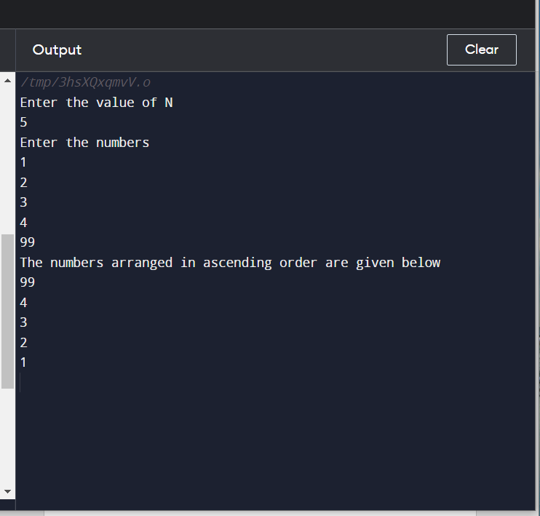

//127 number is even or not

#include <stdio.h>

//input= 2 4 6 10 15

//expected output =2 4 6 10

void fun();

int main()

{

fun();

}

void fun()

{

int i, j, a, n, number[30];

printf("Enter the value of N \n");

scanf("%d", &n);

printf("Enter the numbers \n");

for (i = 0; i < n; ++i)

scanf("%d", &number[i]);

for (i = 0; i < n; ++i)

{

if(number[i]%2==0)

printf("%d is even\n",number[i]);

}

}

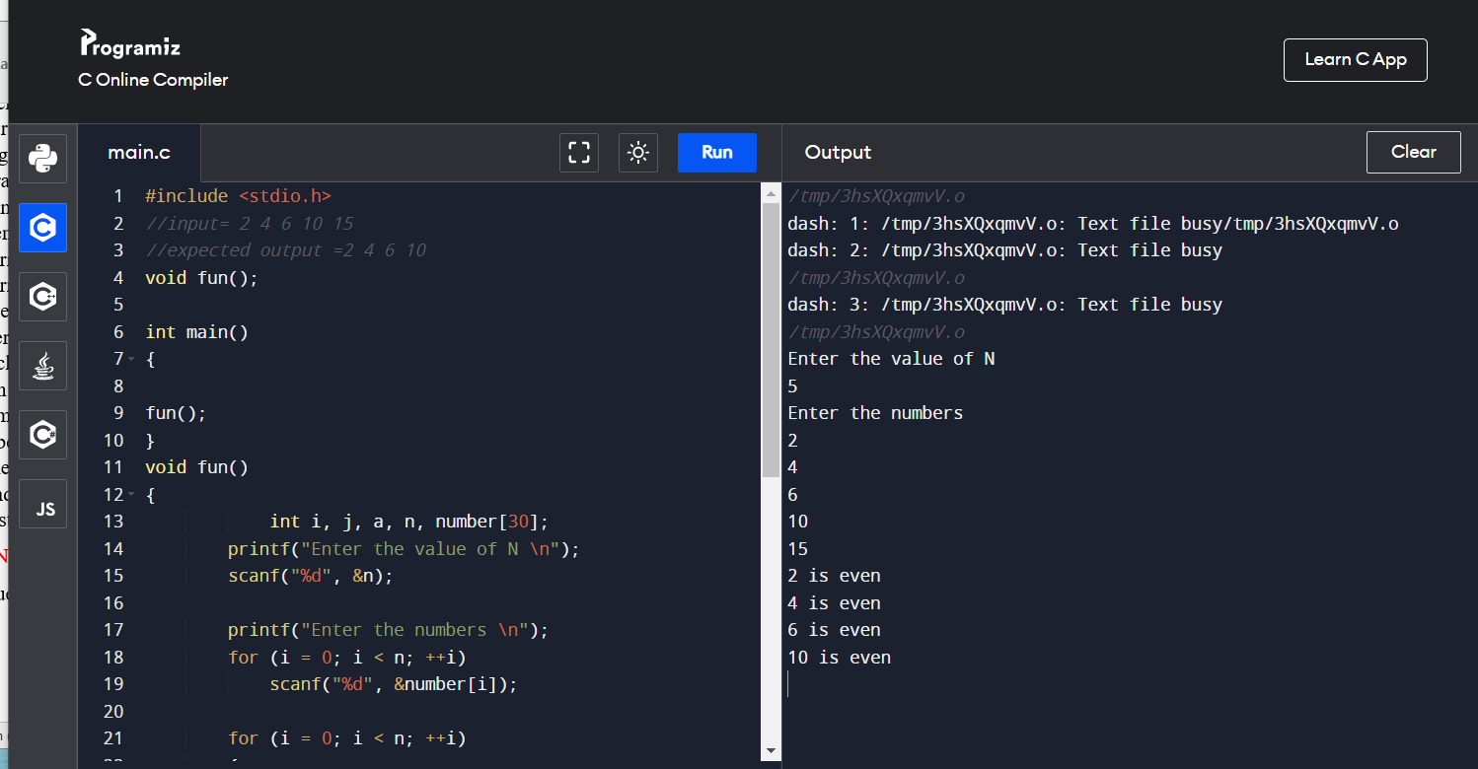

//128 progrm to print odd number

#include <stdio.h>

//input= 1 3 5 8 6

//expected output =1 3 5 ,3

void fun();

int main()

{

fun();

}

void fun()

{

int i, j, a, n, number[30],count=0;

printf("Enter the value of N \n");

scanf("%d", &n);

printf("Enter the numbers \n");

for (i = 0; i < n; ++i)

scanf("%d", &number[i]);

for (i = 0; i < n; ++i)

{

if(number[i]%2==1)

{printf("%d is odd\n",number[i]);

count++;

}

}

printf("total odd no are:%d",count);

}

// 130 Addition of each element of array

#include <stdio.h>

//input= 12 123 1234 12389

//expected output =2 3 4 5

void fun();

int main()

{

fun();

}

void fun()

{

int n,r,sum,arr[10],i,temp;

int count = 0;

// iterate at least once, then until n becomes 0

// remove last digit from n in each iteration

// increase count by 1 in each iteration

printf("Enter size of the array : ");

scanf("%d",&n);

printf("Enter elements in array : ");

for(i=0; i<n; i++)

{

scanf("%d",&arr[i]);

}

for(i=0; i<n; i++)

{

temp=arr[i];

while(temp!=0)

{

r = temp%10;

count++;

temp/= 10;

}

printf("Number of digits is %d\n", count);

count=0;

}

}

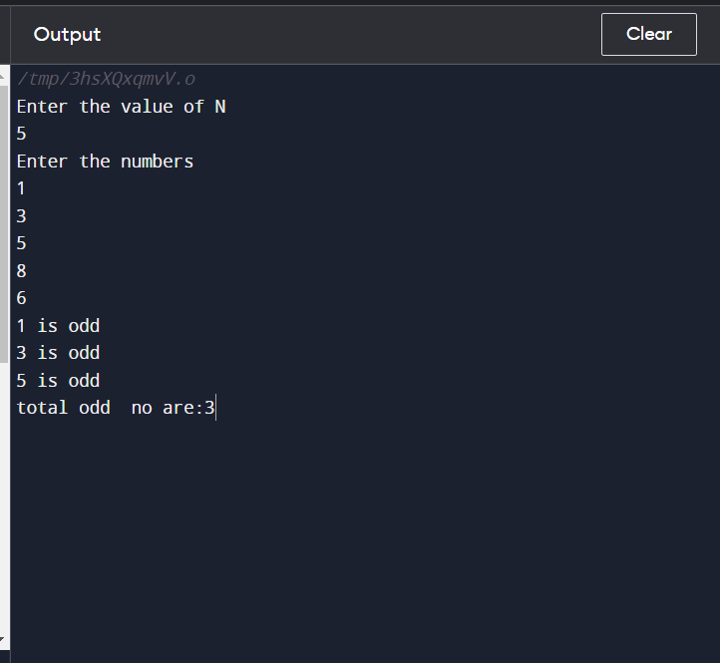

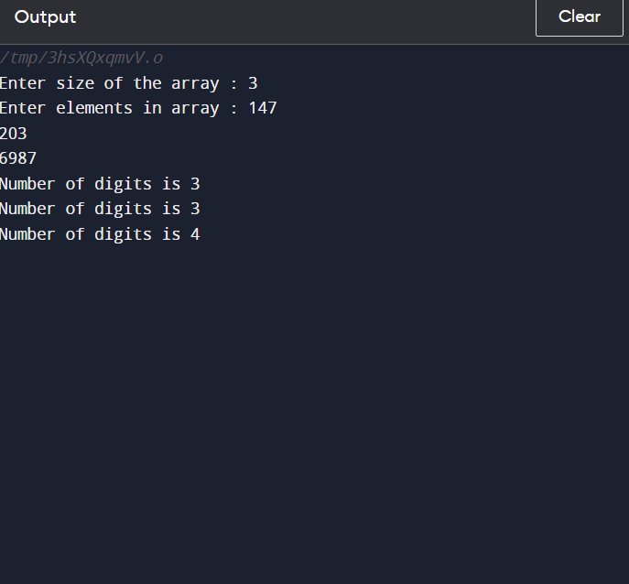

//132 Write a program to find prime numbers ina Array

#include <stdio.h>

//input= 1 3 5 9 10 12

//expected output =1 3 5 9

void fun();

int main()

{

fun();

}

void fun()

{

int n,arr[10],i,temp,k,flag=0;

int count = 0;

printf("Enter size of the array : ");

scanf("%d",&n);

printf("Enter elements in array : ");

for(i=0; i<n; i++)

{

printf("storing value at %d",i);

scanf("%d",&arr[i]);

}

for(i=0; i<n; i++)

{

temp=arr[i];

for(k=2;k<temp;k++)

{

if(temp%k == 0)

flag=1;

}

if(flag==0)

{

printf("%d is prime\n",arr[i]);

count++;

}

}

printf("Number of prime numbers in aarry is %d\n", count);

}

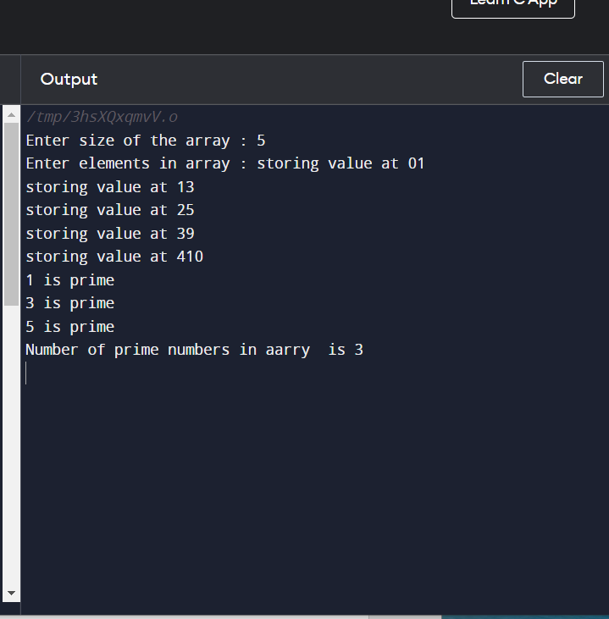

With Argument and no Return Value